**Bread & Butter Buy Setups**

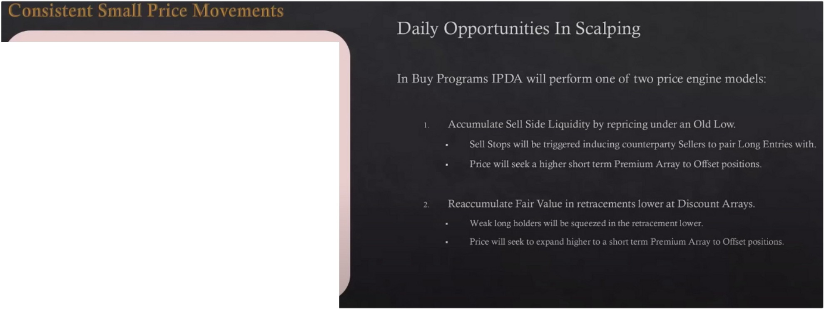

**Buy Program**

**Offset Accumulation**

I

**Reaccumulation**

I

I

We focus on small price movements that can be harvested just about every day, not every day tho

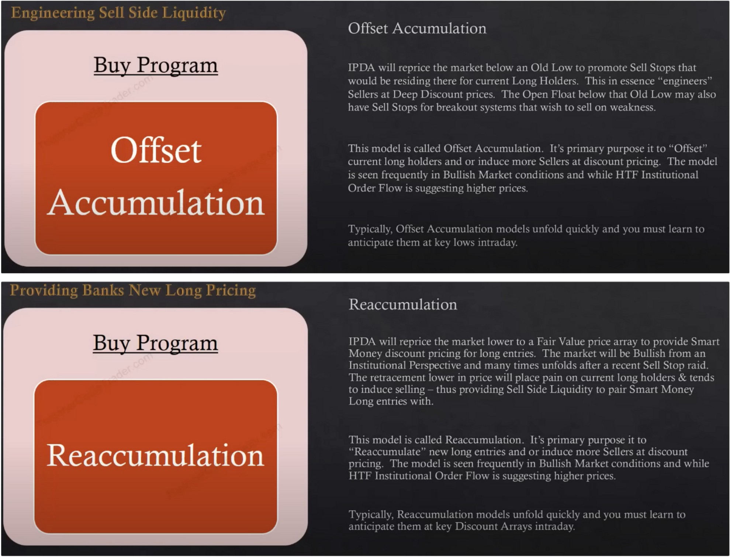

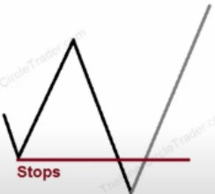Trade duration is many times a lot less then 2 hours but 2 hours is the maximum

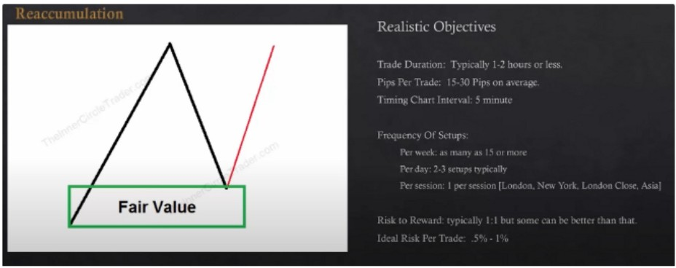

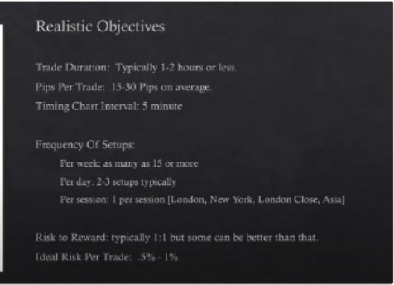

This is turtle soup This one is basically OTE

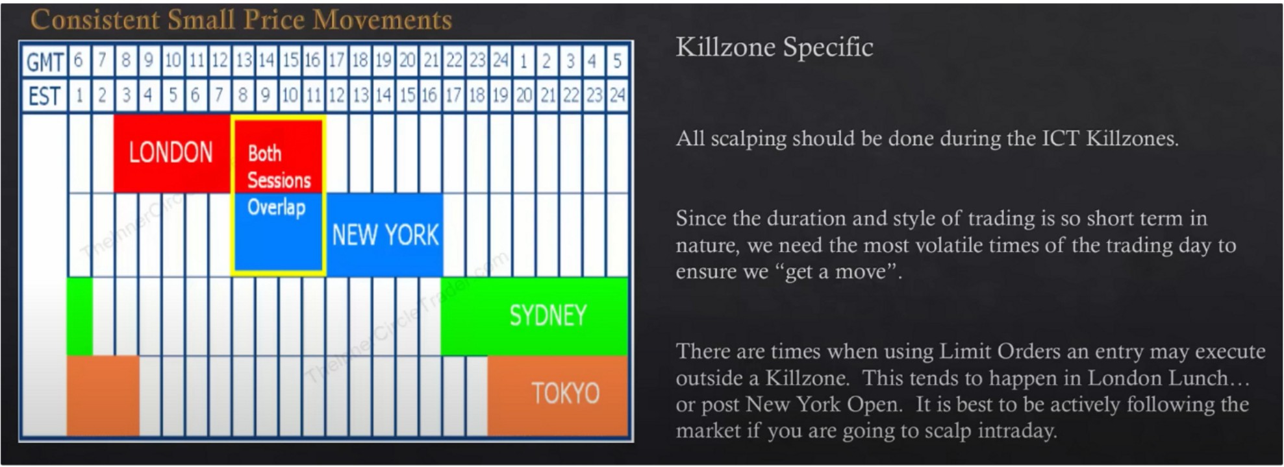

Try to do all your scalping with market orders, if youre going to scalp then just use market orders

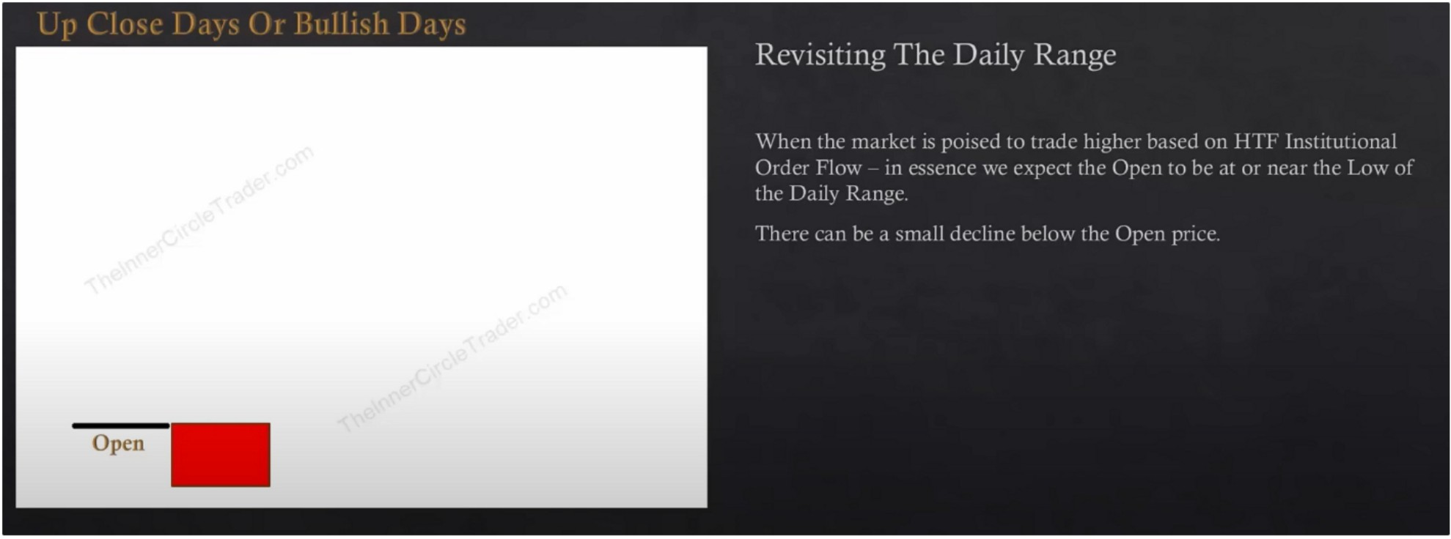

We look at both openings, 0 GMT and MNO

HTF institutional orderflow is the monthly weekly daily and 4h. We also look at the IPDA data range, where is the quarterly shift recently are we looking to go higher or lower? Are we recently trading off of daily bullish discount arrays? Are we seeing bullish orderblocks get respected and bearish orderblocks failing? Are we coming down and filling in liquidity voids and rallying? What that is telling you is that institutional orderflow is bullish. You need to see what price is doing, how is it supporting? Are upclosed candles being broken? And downclosed candles being respected/finding support for everytime price comes back to it? Thats institutional orderflow, look at it on the **HTF,** MWD and 4h. When you see those evidences in price and you did your PD array matrix and you see where those PD arrays are, where is the one where your most likely going to see a long entry, Its the next one that price trades to. Once you get in there youre going to be looking for a premium, a counterparty so that way it frames your trade. We dont use anything else besides institutional orderflow to get to know if the market is bullish or bearish. Are old high breaking but old lows holding? Or are those lows being broken quickly and price snaps higher right away, whats that showing you is that the price model was accumulation. These are all characteristics of IPDA showing institutional orderflow is bullish

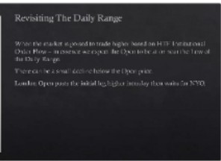

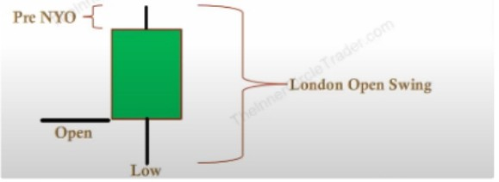_, }LoodooOpcoS•·mg Opco

-L•w

London open swing usually does around 40-60% of the daily range before we get to 5am London lunch is usually a retracement or consolidation

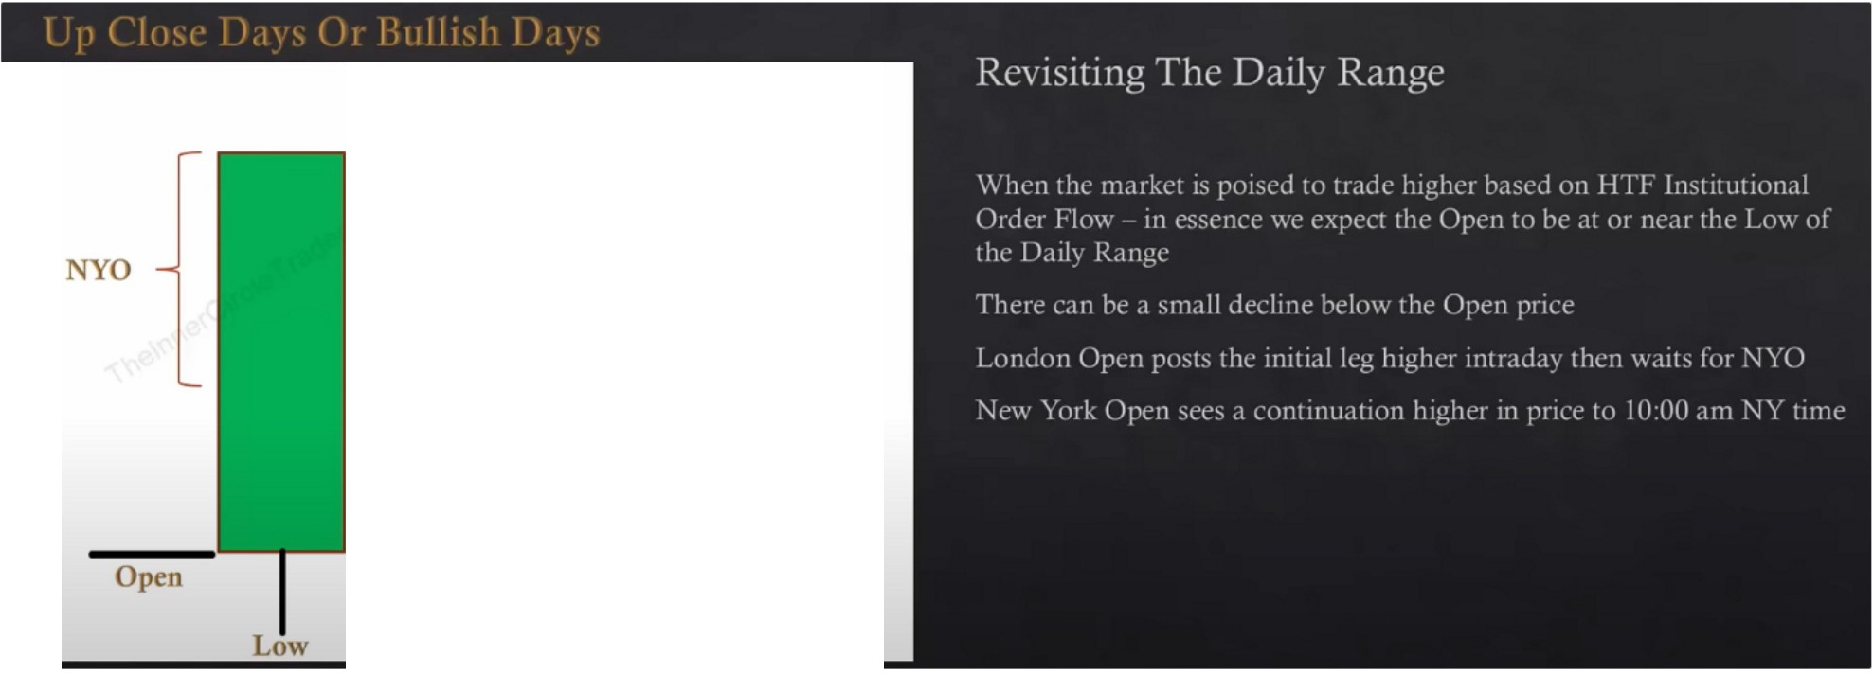

**London Open Swing**

10am new york time is where it starts to consolidate or create the high of the day and retrace a little bit or it could be a complete market reversal but thats not our focus right now

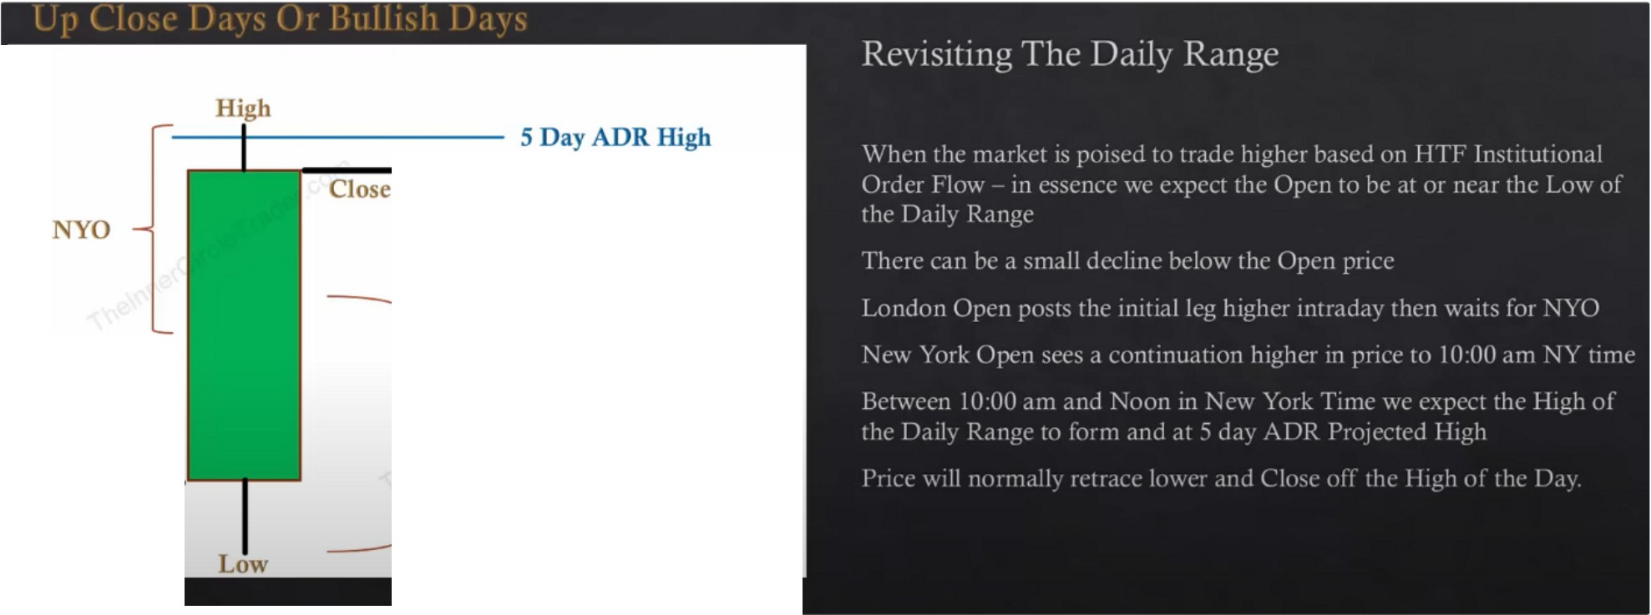

**London Open Swing**

**Open**

Price should hit the 5 day ADR high, combine that with projections and PD arrays to get very precise

On highly explosive moves, then price will likely explode way higher The London Open

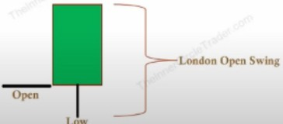If the market is busy and they trade trough lunch then the retracement can be during lunch and give an early entry. Generally when the market in London was very volatile or it was quiet early in

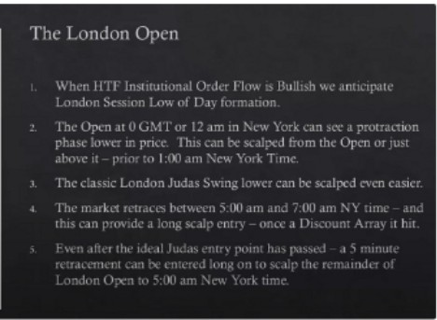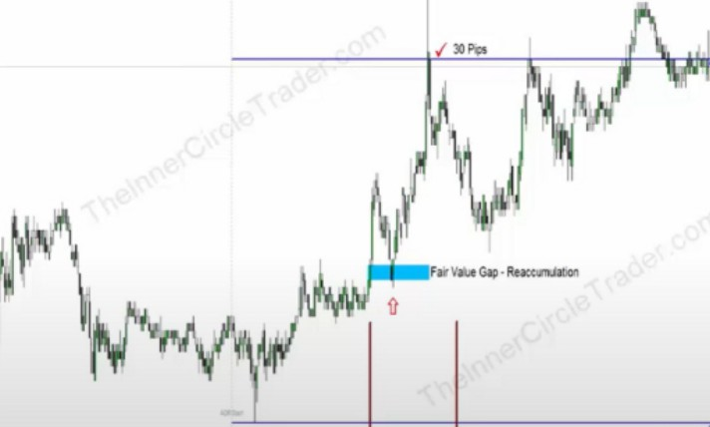

""""'°'"'

-,-

london and then towards the 430am when news comes out it gets really active, usually it will crossover into london lunch and youll get maybe a small 15 to 20 minute consolidation and then get the retracement back into until new york and then it runs. Not always but sometimes the entry point would be really good in lunch, but its better to not even trade that time and dont even look at it.

Generally 5m chart is what ICT works off of

The New York Session

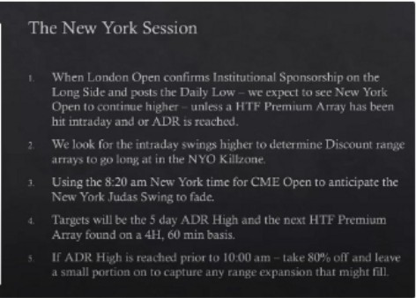

N {

. ....

·--"•

**.JoaOpns ,**

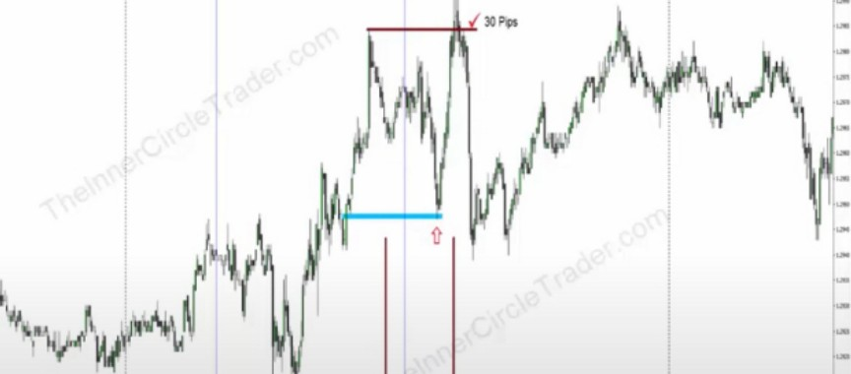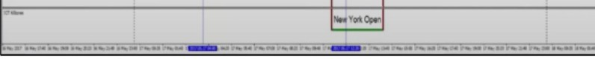

Point 2 is basically about OTE trade entries long

Every session has a protractionary market stage, a judas swing. If were bullish we look for a drop after CME opening for the new york sessions, and for london its the MNO, in asia its 0 GMT, for london close its 10am but at london close on a bullish day we expect a rally and then a downmove to close the day

The London Close

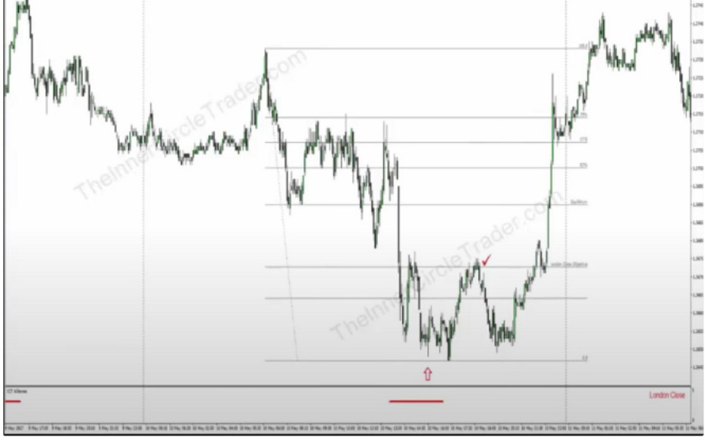We use 10 pips SL below the low so we wouldve still been in

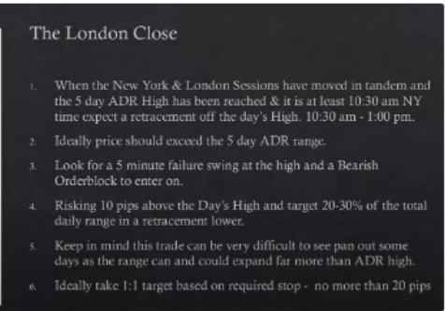

L.;:n-{

**r**,_

-

**SDayADlllllp**

o;;;--

For the SP500 you have two trends, the AM and PM session. You have an AM trend and PM trend, but the characteristics that you see for london close for forex is the same thing that daytraders do for SP500, London traders on SP500 are going home at the same time. SO THIS WORKS ON SP AND OTHER INDICES ALSO!

Between 10:30am and 1:00pm thats where we look for that setup

The 5th point is qhy ICT doesnt trade London close anymore, but when we get into SP500 later on its a little bit more favourable trading that as an index, so it works better on SP500, probably because it moves more?

Aim for max 15-20 pips

The london close objective is 30% on the fib and 20% is the lower level, in between those 2 lines is usually where the market will reach up into. Thats also good for daytrading, because you can draw it on the london low and extend it to the 5 day ADR high and at the 20% thats usually where the close will be.

The Asian Open

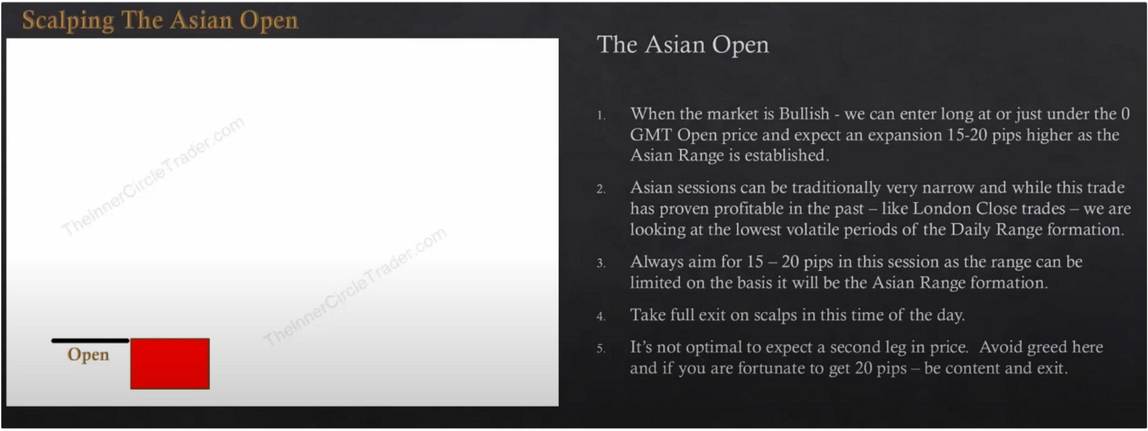

Asian open and london close are the 2 smallest tiniest windows of opportunities and it doesnt pay out enough for the risk in ICTs opinion

Its a bit weird, because we expect and hope the asian range will be small ahead of london but then we try to trade it, so theres a confliction between the rules, not worth it in ICTs opinion. He shares it because he will get these questions. He wont trade these kind of setups, unless its a market

reversal day then he will go all in on london close. Same for asia if its going to be trading down to a **HTF** discount array and didnt get there in new york and is hovering above it he would look for asia to do it and make the low of the day

Arjo I Twitter, lnstagram I Linktree

Linktree. Make your link do more.

I https://1.co/HhmmTN1fUI

JavaScript is not available.

***"JI*** https://twitter.com/arjoio